# Union All Transformation in SSIS

## Visual Data Flow Diagram

This diagram illustrates how two sources feed into the Union All transformation and then into a single destination.

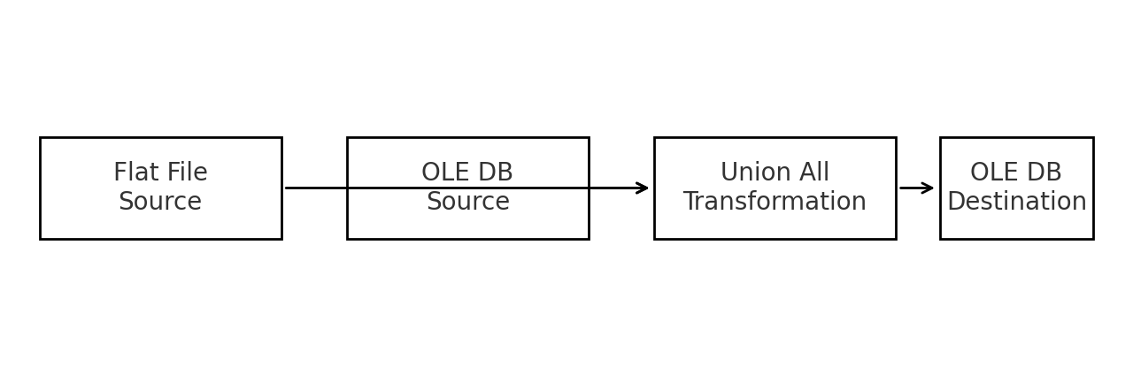

## 1. Introduction

Definition:  
The Union All Transformation in SSIS combines data from multiple input sources into a single output dataset without removing duplicates.  
  
Key Point:  
- Similar to the SQL UNION ALL operator.  
- Appends rows from multiple sources.  
- Unlike UNION in SQL, it does not perform a distinct operation — duplicates remain.  
  
Use Cases:  
- Merging data from different files into one dataset.  
- Combining records from multiple database tables.  
- Consolidating data from various sources for reporting.

## 2. Real-World Example

We have:  
- Source 1 → CSV file  
- Source 2 → SQL Server table  
We want to combine both datasets into one output and load it into a final destination table.

## 3. Step-by-Step Implementation

### Step 1 – Create a New SSIS Project

- Open SQL Server Data Tools (SSDT) or Business Intelligence Development Studio (BIDS).

- Create a New Integration Services Project.

- Rename the package if needed.

### Step 2 – Add a Data Flow Task

- Drag a Data Flow Task from the SSIS Toolbox to the Control Flow.

- Double-click to open the Data Flow tab.

### Step 3 – Add and Configure Sources

- Source 1 – Flat File Source (CSV File):

- 1. Drag Flat File Source into the Data Flow.

- 2. Double-click → Create a new Flat File Connection Manager.

- 3. Browse and select your CSV file.

- 4. Preview to confirm the data.

- 5. Click OK.

- Source 2 – OLE DB Source (SQL Table):

- 1. Drag OLE DB Source into the Data Flow.

- 2. Double-click → Create a new OLE DB Connection Manager.

- 3. Select your SQL Server database.

- 4. Choose a table or write a SQL query.

- 5. Preview to confirm the data.

### Step 4 – Add Union All Transformation

- Drag Union All Transformation into the Data Flow.

- Connect both sources (Flat File Source and OLE DB Source) to the Union All component.

- If prompted for Input Column Mapping, ensure:

- - Columns from both sources have the same data type and order.

- - Rename columns or use Data Conversion if types don’t match.

### Step 5 – Add Destination

- Drag an OLE DB Destination into the Data Flow.

- Connect Union All output to the destination.

- Configure OLE DB Destination:

- - Select the server and database.

- - Choose an existing table or click New to create one.

- - Map source columns to destination columns.

### Step 6 – Execute the Package

- Save the package.

- Press F5 or click Start Debugging.

- The Progress tab should show:

- - Rows read from both sources.

- - Rows combined in the Union All.

- - Rows inserted into the destination.

### Step 7 – Verify Results

- Run a SQL query in SSMS:

- SELECT * FROM FinalTable;

- You should see:

- - Records from both sources combined.

- - Duplicate records preserved.

## 4. Key Notes

- Data Type Matching: All input columns must have compatible data types.  
- Column Order: The column mapping is position-based; ensure correct order.  
- Duplicates: If you want to remove duplicates, use Sort Transformation with 'Remove rows with duplicate sort values' enabled.  
- Performance Tip: Avoid unnecessary conversions; match source column data types beforehand.